Software Requirements Specification
For
FOOD FOR NEEDY
Version 1.0 approved
Prepared by,
GURU PRASHATH M
BHUVANESHWARI.K
Vellore Institute of Technology
11/20/2021
Table of Contents
Table of Contents ii
Revision History ii
1. Introduction 1
1.1 Purpose 1
1.2 Document Conventions 1
1.3 Intended Audience and Reading Suggestions 1
1.4 Product Scope 1
1.5 References 2
2. Overall Description 2
2.1 Product Perspective 2
2.2 Product Functions 2
2.3 User Classes and Characteristics 2
2.4 Operating Environment 3
2.5 Design and Implementation Constraints 3
2.6 User Documentation 3
2.7 Assumptions and Dependencies 3
3. External Interface Requirements 4
3.1 User Interfaces 4
3.2 Hardware Interfaces 4
3.3 Software Interfaces 4
3.4 Communications Interfaces 5
4. System Features 5
4.1 Signup 5
4.2 Login 6
4.3 Request Module 6
4.4 Donation Module 7
5. Other Nonfunctional Requirements 7
5.1 Performance Requirements 7
5.2 Safety Requirements 8
5.3 Security Requirements 8
5.4 Software Quality Attributes 8
6. Other Requirements 9
Appendix A: Glossary 10
Appendix B: Analysis Models 10
Appendix C: To Be Determined List 11

Revision History
Name | Date | Reason For Changes | Version

Introduction

Purpose
This document describes the software requirements of a Food for Needy (FFN) System for events or parties or a function. It is intended for user and maintainer of the FFN. These requirements were created in response to donate food for the organization. It will explain the different functional requirements of the system, the interfaces of the system, what the system will do or how the system will interact with the external users, the constraints under which it will operate. It also gives us the view about what are the users expectations. The end users will be able to use this SRS as a tool to see if the constructing team will be constructing the system to their expectations. If it is not to their expectations the end users can specify how it is not to their liking and the team will change the SRS to fit the end users’ needs.

Document Conventions
The document is prepared using Microsoft Word 2019 and has used the font type ‘Times’. The fixed font size that has been used to type this document is 12pt with 1.15 line spacing. Sectional headings use ‘Times’ font with 18pt and sub-sectional titles use ‘Times New Roman’ font with 12pt.It has used the bold property to set the headings of the document and key points in the document as a highlighting option. Standard IEEE template is the template used to organize the appearance of the document and its flow

Intended Audience and Reading Suggestions
The intended audience of this document would be the FFN system administrator and the project team to refer and analyze the information. Also, it could be used by potential developers, design engineers, testers, etc. Readers are suggested to know basics of SRS and the outline of how the FFN system works. The end users are suggested to use this SRS as a tool to see if their expectations are met and modify if any changes are required by informing the team.

Product Scope
Our main objective is not to waste food. The farmer’s effort and hard work not to be wasted. At least a poor guy can feel the taste of the food on donating it. Today’s wastage is tomorrow’s shortage so we trying build a system with that we going to find the food needy and donors.

References
- SRS Template:
IEEE Template → https://web.cs.dal.ca/~hawkey/3130/srs_template-ieee.doc

- https://projectsgeek.com/2020/02/food-donation-project-system-free.html

- https://nofoodwaste.org/donate

Overall Description

Product Perspective
The proposed application will provide a platform for donors and seekers after they successfully register into the system. If a donor wishes to donate something, he/she can send a message in application. This message will be shown as notification in donations tab to other donors. This message will be stored in back-end in the database. Once a notification is sent, the orphanages who wish to claim the donations can reply to the donor and contact him/her. The user interface of this system will be simple and user-friendly, and the targeted system is android. At present, we are aiming to avoid the major wastage that usually happens in India and that is foodstuffs.

Product Functions
- Register Module
- Login Module
- Request Module
- Donation Module

User Classes and Characteristics
• Admins- Must be able to access the database, manage donors and organization’s profile .

• Donor’s - Able to login and signup, choose organization and specify address & location. He /She can also put up items for donation and view all donation.

Operating Environment
- A machine capable of running Windows XP and 512mb free ram after the OS has been started.
- For Linux it is a similar 512mb free ram after the OS has been started.
- Basic text field entry and typing skills are assumed by all users

Design and Implementation Constraints
The following software & hardware equipment are required for implementation and for the design:
1. Visual Studio Code and the Scripting language used is HTML, PHP, CSS
2. Microsoft Word for documentation purposes.
3. Keyboard and a mouse will be required for interaction with the application.
4. Also ensuring certain constraints like reusability, maintainability, testability, and safety would enhance the software application.

User Documentation
- Documentation is mainly intended for database administration for understanding how to handle database entry and editing.
- They are expected to understand whatever database administration program they prefer that supports reading and editing databases.
- Basic knowledge on operating some applications on windows medium would help the end users.

Assumptions and Dependencies
- The system is storing all the data at one place but the access is restricted among its users as per prior knowledge about the requirements.
- Basic text field entry and typing skills are assumed by all users.
- The function to fill up the form which requires the User to be connected to the internet.
- Basic knowledge on operating some applications on windows medium would help the end users

External Interface Requirements

User Interfaces
• Welcome screen: This screen displays the Home page for the application which includes login, signup, Organization, Send Request, View Request.

• Login/Signup: This screen displays the login and signup credentials where the donors can sign up and login.

• Organization: This screen displays the available organization.

• Request Page: This screen displays a form where the organization request for the food by filling their name, corresponding date and time.

• Donation Page: This screen also displays a form where the donors can fill up their form by their choice / needs.

Hardware Interfaces
There are no such hardware interfaces, just a windows-based computer that support the use of key board and mouse for entering the data /details and navigation is required.

Software Interfaces
Front end - Html is used to create web page for the software in which the login, selecting the organization, request & donation page and contact us page are available for the user to Interact.

Back end -Php is used to create the back end of the software which link with the front end of software.
• Login screen back end get the ID and password from the donor and verify it. If Id and password are valid, software moves to the next screen or If ID and password is invalid software asks to re-enter the details.
• View Request Page shows various requests from the organization so that donors can donate.
• Send Request Page where the organization request for food.
• The Contact us page are used to get issues / queries by the users.
• Donation Page where the donors donate to the respective organization.

Communications Interfaces
- The communication between web page and the program is established by Php.
- Data and the inputs that are provided in the web page are transfer to the program to manipulate the information and create the output that is to be displayed on the output screen

System Features
The following are the main features for online invitation preparation.

4.1 Sign up

Description and Priority:
The donors enter the needed details to create an account in this application. This feature has a high priority without an account donor cannot use this application.

Stimulus/Response Sequences:
The donor has to enter the following details 1.username 2.email address 3.password 4.phone number .Once the details are validated and an account is created an email saying the same is sent to the respective account confirming the successful creation of the account.

Functional Requirements

REQ-1 a database to store the valid donor credentials

REQ-2: A program that accepts, validates, stores the donor credentials

4.2 Login

4.2.1 Description and Priority

The donor has to enter the username or email id and the password that has been given during the signup phase. The credentials are validated and the donor is given access to the application if the credentials are valid else needs to re-enter the credentials. This feature has a high priority.

4.2.2 Stimulus/Response Sequences

The donor has to enter the following detail

Email address
  - Password

Once the credentials are validated depending on whether the details are correct or not the donor shall be given access to the materials of the application, in-case the login details don’t matchup his/her request for login may be rejected after which the donor has to re-enter the details correctly.

4.2.3 Functional Requirements

REQ-1: The database in which the donor credentials are stored
REQ-2: A program that accepts the credentials entered and validates. If details are right the program lets the donors in and if the details don’t match the donor is requested to enter the credentials again

Request Module

Description and Priority
The organization has to give request for the particular date and time. This feature has high priority because without this feature donor doesn’t know which organization was in the need for food.

4.3.2 Stimulus/Response Sequences
The organization has to give request for need so that the application accept, and make it available for the donors to choose the organization.

4.3.3 Functional Requirements

REQ-1: The database in which the possible request are stored

REQ-2: A program that displays, accepts the organization’s input and ushers the donors to the next phase of the application.

Donation Module

4.4.1 Description and Priority
The donor can choose the organization according to the need or to the user’s choice.
He/she can donate food. This is a high priority feature.

4.4.2 Stimulus/Response Sequences
The donor has to select an organization to start donation. The application program accepts the choice.

4.4.3 Functional Requirements

REQ-1: The database in which the possible donations are stored

REQ-2: A program that displays, accepts the donors input

Nonfunctional Requirements

Performance Requirements
• Speed - The usage experience should be smooth and fast. The speed of the system should not affect if the number of users increased. The system’s response time should also be very short for the user’s data access requests. Search and loading functionalities should be faster for a better end-user experience.

• Scalability -The system should be scalable to support a large user base.

• Performance statistics - Performance for data entry is dependent upon the programming language used and the machines implementing the application. This should be negligible. The biggest drag on performance will be accessing the database. We are keeping our queries simple to counter the slow execution of queries

Safety Requirements
The user must enter their fields with correct specified data type (Option for the occasion, user credentials, format, etc.) to prevent any data integrity constraints that may lead to small crashes or wrong results in the system.

Security Requirements
Security is used to ensure login details as confidential and it is not stored anywhere. The user can see their data only when they enter their information in the respective fields. System Administers are trained on customer privacy.

Software Quality Attributes
• Correctness: Satisfy the Donation operations precisely to fulfil the end user objectives.

• Efficiency: Enough resources to be implemented to achieve the particular task efficiently.

• Flexibility: Flexible enough to provide space to add new features and to handle them conveniently.

• Integrity: Focus on securing the user information and avoid data losses as much as possible

• Portability: Should be able to have modifications to support the software run in machines that have any environment (operating system).

• Usability: Provide user manual to every level of users.

• Quality Assurance: We will all be responsible for quality assurance. We will cross check the system implementation with the System Requirements to verify system accuracy

• Maintainability: After each revision the system will be analyzed and compared with the system requirements designated by the client. We will than try to break the program with test cases.

• Testability: Able to be tested to confirm the performance and specifications

• Robustness: Strength of the system to handle the system functions accurately and maintain the database without facing unexpected failures.

• Reliability: Specify the factors that are required to establish the reliability of the software system at the time of delivery.

• Availability: The system shall be available during normal donation page preparation.

• Reusability: What is the ability to use the available components of the system in the other system as well?

• Documentation: All final documents will be reviewed for spelling errors, broken links, and any other issues that affect the quality of the document. Any errors found in either the system or supporting documents will be fixed at the time errors are found.

Other Requirements
• This project supports existing infrastructure requirements and provides specific recommendations for hardware and network solutions based on existing and projected user needs.

• Application requirements, data resources, and people within an organization are all important in determining the optimum hardware solution.

• It shows the components of the system, the services they provide and the way they communicate to bring about the system functionality.

Appendix A: Glossary
1. FFN – Food For Needy
2. SRS – Software Requirement Specifications
3. OS – Operating System
4. IEEE – Institute of Electrical and Electronic Engineers
5. End User - Customers who are willing to plan their travel through the System.
6. Admin / Administrator – People who manage the database and look over the actual travel implementation
7. Donors – People who donated for the respective organization.
Appendix B: Analysis Models
USE CASE DIAGRAM
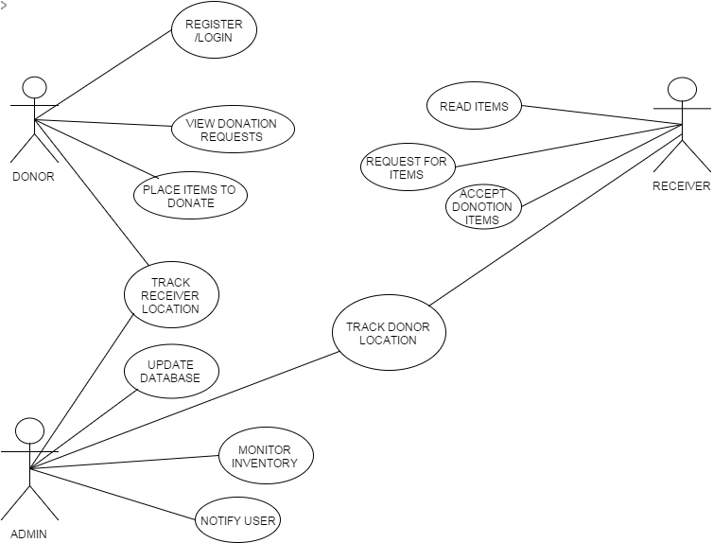
SEQUENCE DIAGRAM
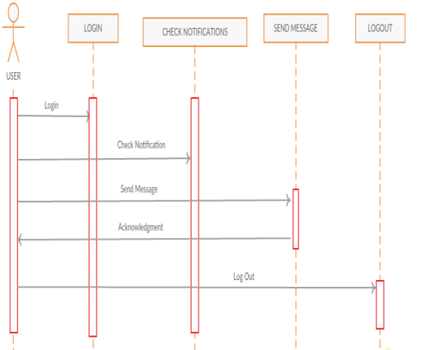

Integration Strategy

For this model we are using Bottom up integration as we know
all the components of the and sub modules of the project ,So we can go for Bottom-up strategy.

What is Bottom Up Testing?
Each component at lower hierarchy is tested individually and then the components that rely upon these components are tested.

Justification:

For this project we used bottom up because this methodology is very useful for applications where bottom up design model is used. It’s easier to create test conditions in bottom up approach to start testing at the bottom level of hierarchy means testing of critical modules or functionality at an early stage. This helps in early discovery of errors. Interface defects are detected at early stage.

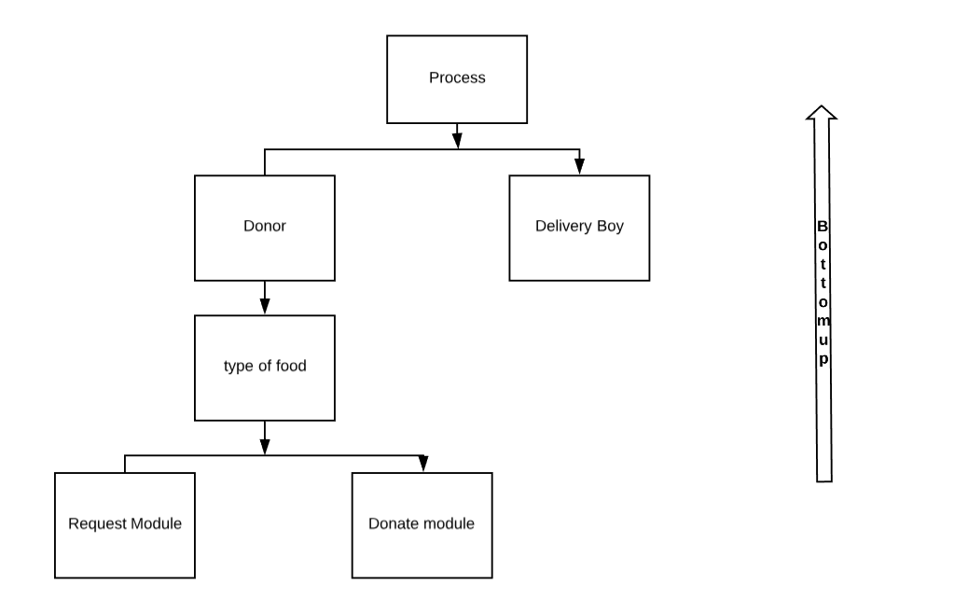
Appendix C: To Be Determined List
1. Memory size of the database – may vary according to number of choices we provide for users.

2. Frequency of backing up data of the database for safety purposes

KNOWLEDGE BASE

1. How can I Donate?
Answer:
First, you have to create an account in our website .Once you created the account,
You can login using your email and password. Now, you can view the request of the
Organization from 'View Request' tab. Then, you knew the organization that you are
Going to donate, you can fill the form in the 'donation' tab.

2. What if I forgot my password for my account?
Answer:
If you forgot your password, you can click 'forgot' button in login page . It will ask for
Parameters such as name and phone number. After that click the retrieve button and then you
Know your password.

3. Will I be able to request food without involving organization?
Answer:
No. We donate food only to organization with whom we have partnered. If you want to be
a part of the organization, you can contact us using our 'Contact us' tab or you can call or mail us .
4. How can I request food?
Answer:
You can join in one of our partnered organization and request on behalf of them.

5. How to report?
Answer:
You can report any issue using 'contact us' tab.

6. How does the website work?
Answer:
The proposed application will provide a platform for donors and seekers after they successfully register into the system.
If a donor wishes to donate something, he/she can send a message in application.
This message will be shown as notification in donations tab to other donors.
This message will be stored in back-end in the database.
Once a notification is sent, the orphanages who wish to claim the donations can reply to the donor and contact him/her.
The user interface of this system will be simple and user-friendly, and the targeted system is android.
At present, we are aiming to avoid the major wastage that usually happens in India and that is foodstuffs.

6. is there any charge for creating an account in 'Food for Needy'?
Answer:
No. You can create your account for free .

7. Do you make any profit from this service ?
Answer:
No. We don't make any profit. Our main objective is not to waste food. The farmer’s effort and hard work not to be wasted.
At least a poor guy can feel the taste of the food on donating it. Today’s wastage is tomorrow’s shortage so we trying build a system with that we going to find the food needy and donors.

8. How often can I donate?
Answer:
You can donate whenever you want as our service 24/7.

9. Will I be able to donate even if there was no request from organization?
Answer:
Yes. You can donate to organizations even when there was no request from them.

10. Will I get a feedback report for my donation?
Answer:
Yes. After sending the donation you will get an appreciation letter for your efforts.

